Data Visualization Assignment
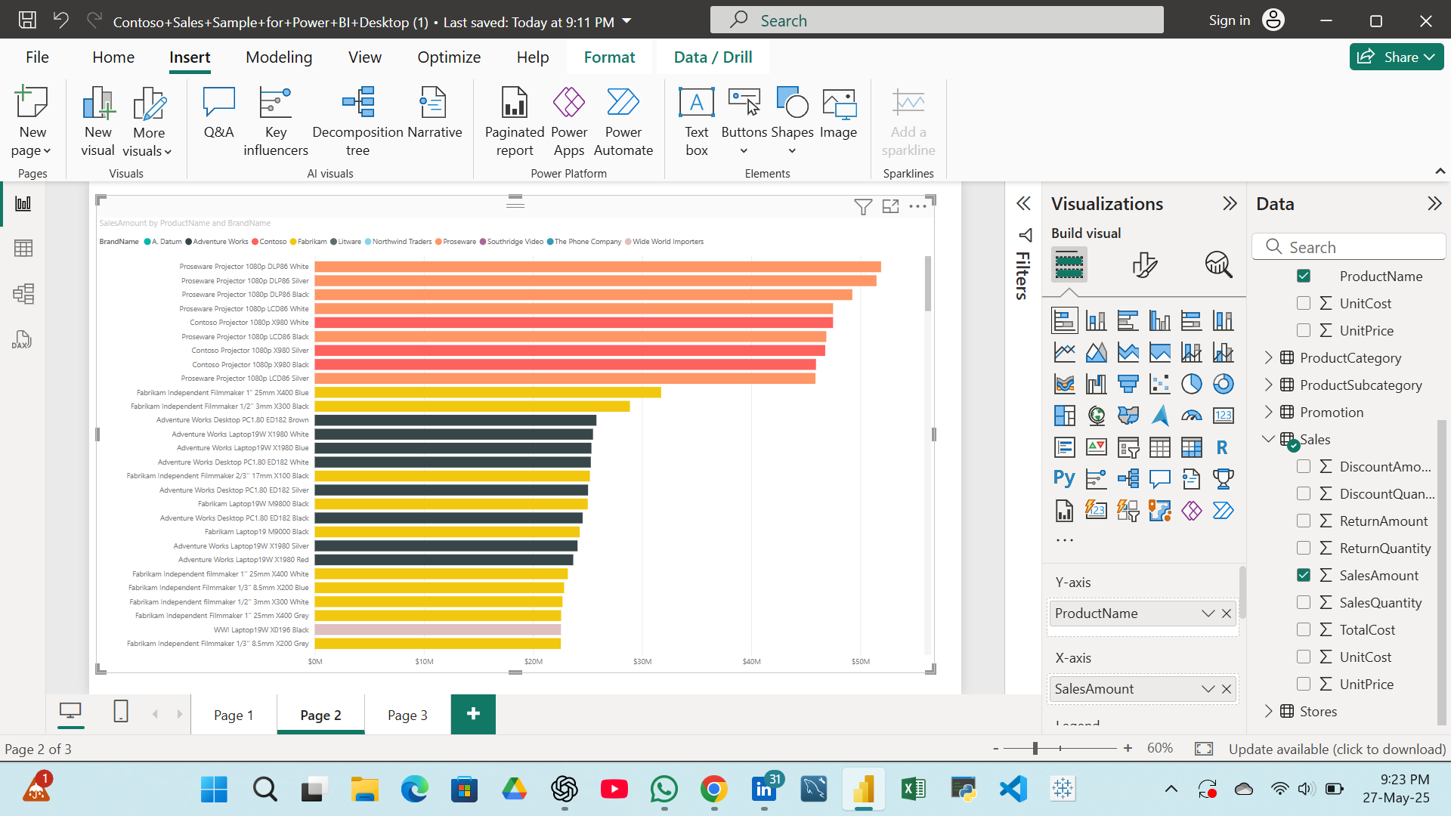
- Plot product name wise SalesAmount using bar chart , apply brandname as legend part.
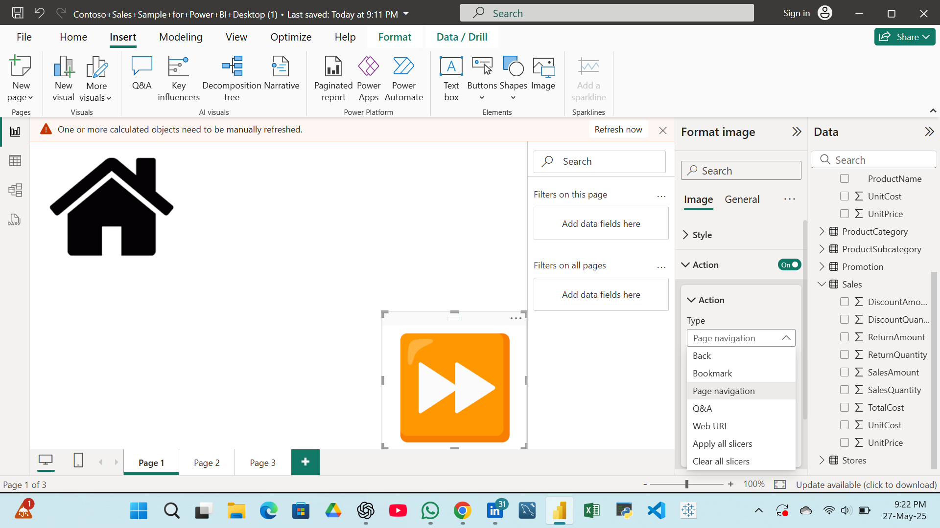
- Apply image as Home and Forward arrow for page to page navigation.
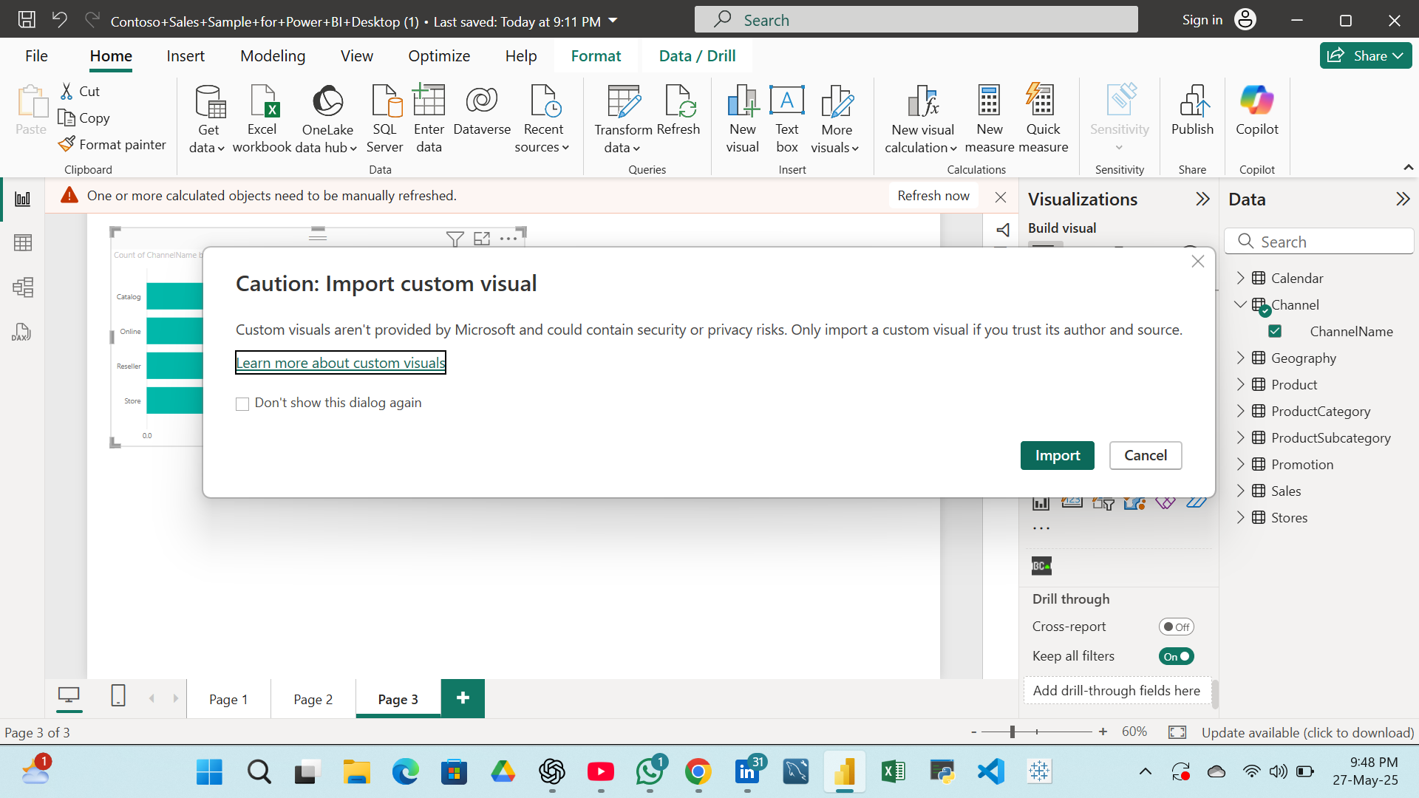
3.Import custom visual as Gantt bar chart and apply it on Channel table, sales table and calendar table.
- Import Of Gantt Chart:-

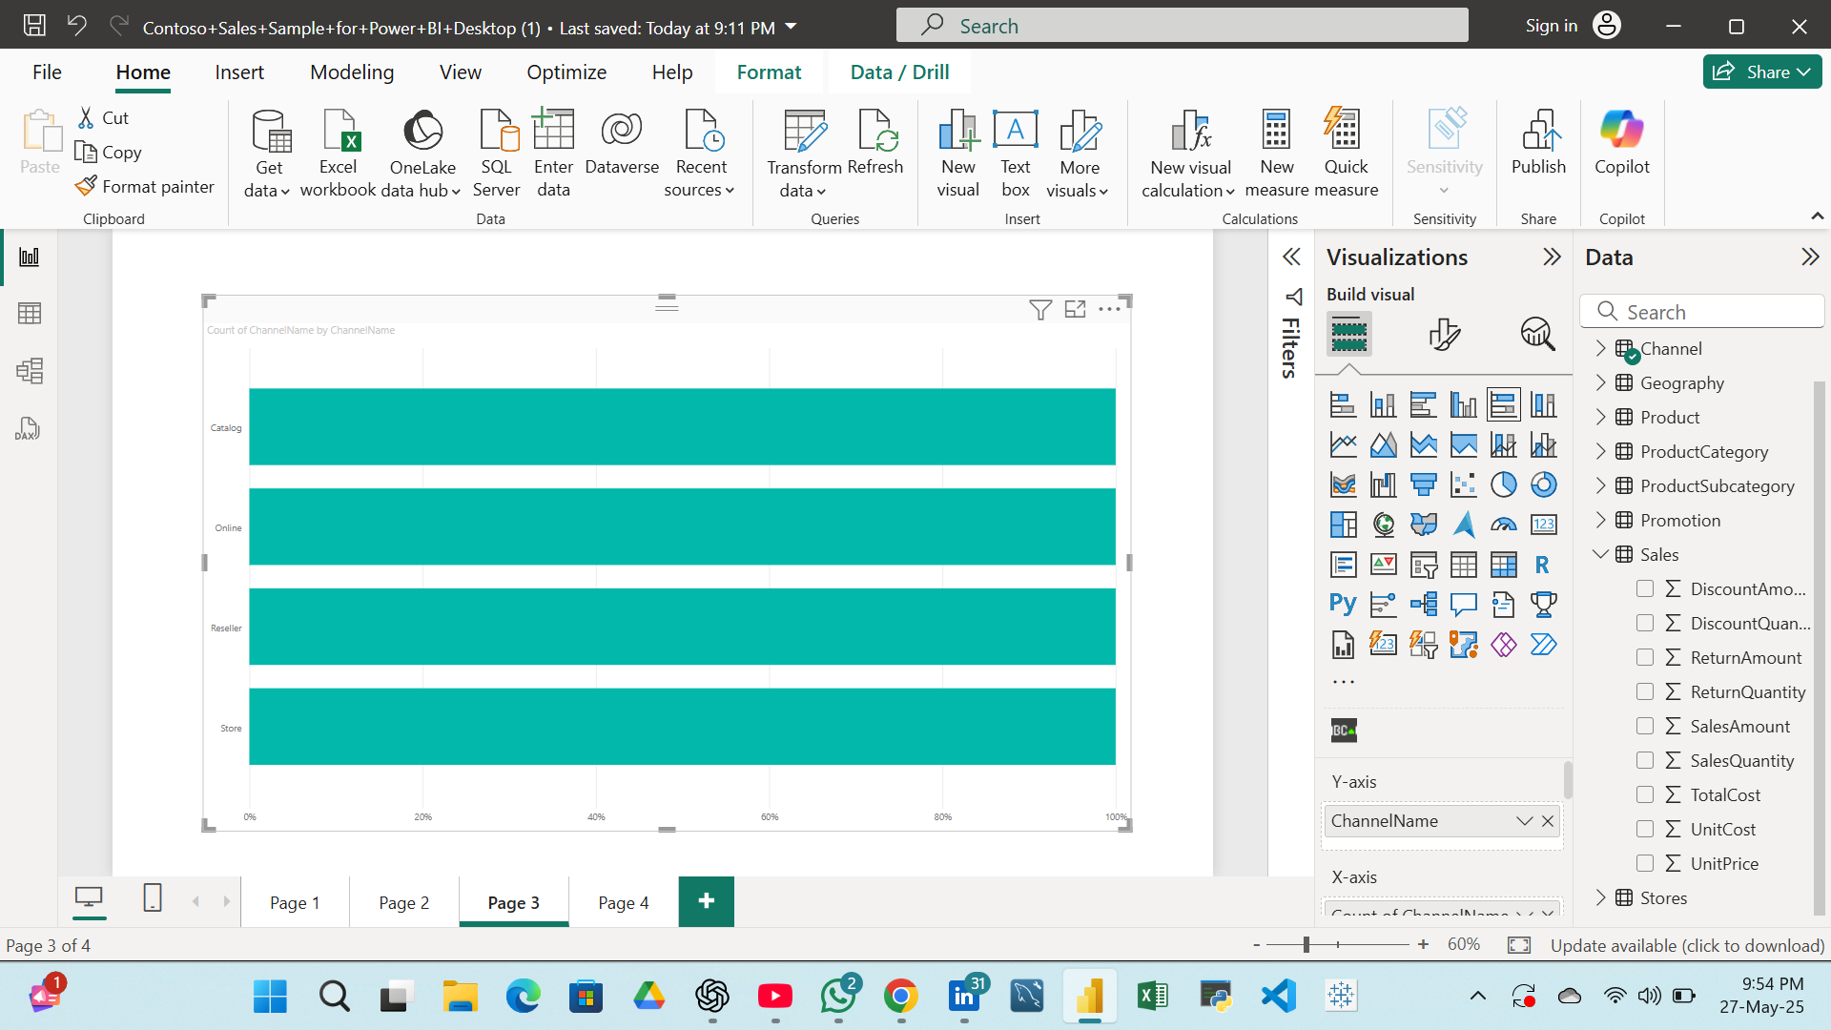
- Bar Chart Channel Wise:-
